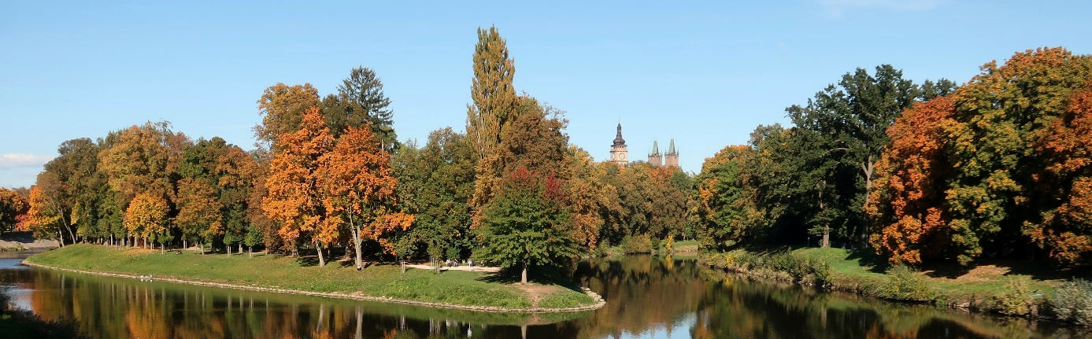
Extension: registration and abstracts until 30 November 2023
The organizers of the
Conference of environmental archaeology 2024
University of Hradec Králové and Museum of Eastern Bohemia

Would like to invite you to the 18th meeting of CEA with topic
Environment and culture
Which will be held on 7 to 9 February 2024 in auditorium of the Museum of Eastern Bohemia, Eliščino nábřeží 465/7, Hradec Králové
The conference will focus on environment and culture. These two phenomena represent two inseparable dimensions that shape the human world. In doing so, the two components influence each other and to some extent condition each other. Therefore, environmental research in the field of archaeology should not be unilaterally focused only on the environmental dimension in its analysis and interpretation, but should also reflect the cultural context of the environmental phenomena studied. The conference organizers hope that papers will focus on different aspects according to the focus of individual researchers, but should always consider both components of the topic. Topics related to questions such as: what is the relationship between the natural environment and social institutions? How does one component respond to changes in the other? What are the differences in the real and symbolic treatment of plants or animals? And the phenomena of inanimate nature? How do different components of nature shape economic or cultural phenomena? Do commonly studied phenomena in one field have unsuspected or hidden connections in the other field? In addition to archaeologists and naturalists, we are also happy to welcome historians, ethnologists and other interested parties.
Web: http://www.iansa.eu/cea
E-mail: klara.burianova@uhk.cz; jan.horak.3@uhk.cz
Fee: 1500 CZK, students presenting a presentation or a poster 1000 CZK
Binding registration until 30 November 2023 via Google form: https://forms.gle/yy7pbVhb7rDefYSSA
Abstract: max 500 words, max 10 references, max 3 figures, via e-mail until 30 November 2023
An invoice will be issued on the basis of this binding registration, you will then pay by bank transfer
The invoice and payment will be issued during January 2024
Programme:
- 7 February 2024: opening of the conference at 13:00, afternoon session
- 8 February 2024: morning session, afternoon excursion, social meeting and dinner
- 9 February 2024: morning session, closing of the conference at 12:00

